OOAD LAB – 3

**Name : Sanmat Sanjayakumar Payagoudar**

**SRN : PES1UG20CS385**

**Section : G**

**Activity Diagram : Job Application**

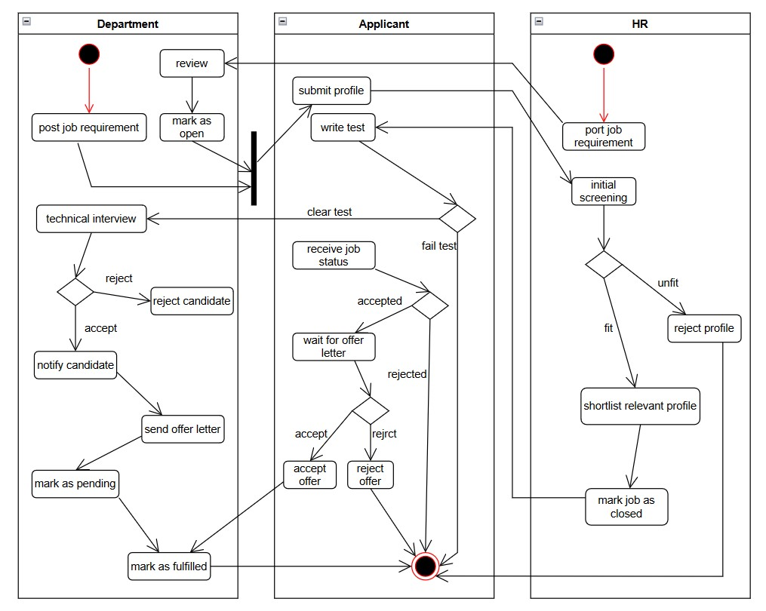

**State Diagram : Job Application**

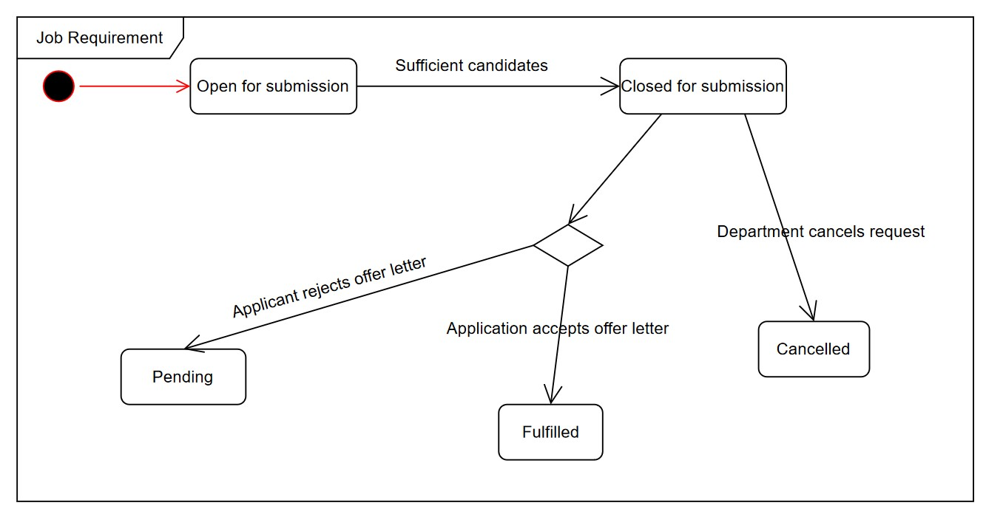

**State Diagram : Application**

